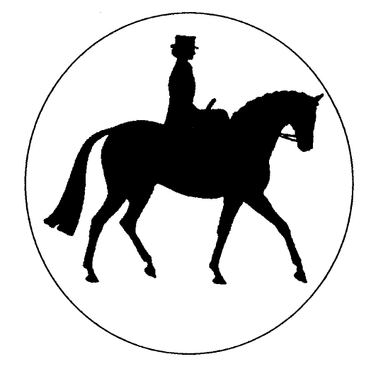The Side Saddle Association®
2021 Classical Ladies Side Saddle Final
(Updated November 2020)

Open to Full Members of the S.S.A., aged eighteen and over on January 1st of the current year, riding side saddle, on horses exceeding 148cms (14.2hh). The class to be judged 25% conformation and action, 25% manners & way of going, 25% rider and 25% turnout of horse & rider, by a SHBGB, BSHC&RHA, BSPS, P(UK) or SSA Panel Judge. Judges may request a short show but will not ride exhibits; horses will not be stripped. Traditional Habits must be worn; Fancy Dress and Period Costumes are NOT permitted. N.B. Silk hats are permitted to be worn in this class AT ANY TIME OF THE DAY..

JUDGES ARE REQUESTED TO USE THIS MARK SHEET

COMPETITOR NUMBER | 118 | 5 | 55 | 31 | 137 | 85 | 103 | 164 | 154 | 35
Conformation & Action (25) | 23 | 19 | 23 | 24 | 22 | 24 | 22 | 23 | 23 | 22
Manners & Way of going (25) | 18 | 20 | 22 | 24 | 22 | 23 | 20 | 22 | 24 | 23
Rider (25) | 20 | 20 | 24 | 23 | 22 | 24 | 22 | 23 | 25 | 18
SUB TOTAL | 61 | 59 | 69 | 71 | 66 | 71 | 64 | 68 | 72 | 63
Turnout of Horse & Rider (25) | 16 | 15 | 21 | 18 | 23 | 24 | 21 | 20 | 23 | 19
TOTAL  (Max 100) | 77 | 74 | 90 | 89+ | 89 | 95 | 85+ | 88 | 95+ | 82
Final Placing |  |  | 3rd | 4th | 5th | 2nd | 9th | 6th | 1st

COMPETITOR NUMBER | 99 | 110 | 139
Conformation & Action (25) | 23 | 22 | 22
Manners & Way of going (25) | 22 | 22 | 23
Rider (25) | 23 | 22 | 24
SUB TOTAL | 68 | 66 | 69
Turnout of Horse & Rider (25) | 18 | 19 | 19
TOTAL  (Max 100) | 86 | 85 | 88
Final Placing | 8th | 10th | 7th

