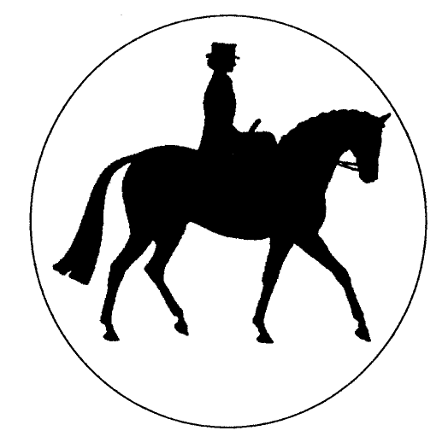The Side Saddle Association®
2024 Contemporary Ladies Side Saddle Final
(Updated November 2022)

Open to S.S.A Adult and Junior members and non-members riding a native part bred heavy or world breed horse/pony side saddle. The class to be judged 25% suitability of horse/pony for rider, 25% manners & way of going for type, 25% rider and 25% turnout of horse/pony & rider. The judge shall be on the current SSA, SHBGB or BSHA Judges panel. Judges may request a short show but will not ride exhibits. Traditional Habits must be worn; Fancy Dress and Period Costumes are NOT permitted. N.B. Silk hats are permitted to be worn in this class AT ANY TIME OF THE DAY.JUDGES ARE REQUESTED TO USE THIS MARK SHEET

COMPETITOR NUMBER | 28 | 101 | 71 | 46 | 145 | 56 | 45 | 81 | 94 | 121
Suitability of Horse/Pony for Rider (25) | 24 | 23 | 21 | 23 | 24 | 22 | 23 | 22 | 23.5 | 21.5
Manners & Way of going for type (25) | 24 | 24 | 23 | 23 | 23 | 23 | 22 | 23.5 | 23 | 23
Rider (25) | 24 | 24 | 22 | 24 | 23 | 21.5 | 23 | 22 | 24 | 23
SUB TOTAL | 72 | 71 | 66 | 70 | 70 | 66.5 | 68 | 67.5 | 70.5 | 67.5
Turnout of Horse/Pony & Rider (25) | 21.5 | 22 | 22 | 22.5 | 20 | 24.5 | 21 | 24 | 20 | 19
TOTAL  (Max 100) | 93.5 | 93 | 88 | 92.5 | 90 | 91 | 89 | 91.5 | 90.5 | 86.5
Final Placing | 1st | 2nd | 9th | 3rd | 7th | 5th | 8th | 4th | 6th

COMPETITOR NUMBER | 76 | 132 | 24 | 60
Suitability of Horse/Pony for Rider (25) | 21 | 23 | 21 | 21
Manners & Way of going for type (25) | 21 | 22 | 21 | 19
Rider (25) | 19 | 23 | 20 | 20
SUB TOTAL | 61 | 68 | 62 | 60
Turnout of Horse/Pony & Rider (25) | 21 | 19.5 | 18 | 17.5
TOTAL  (Max 100) | 82 | 87.5 | 80 | 77.5
Final Placing |  | 10th

